**LAB # 04**

**SUPERVISED LEARNING (NAÏVE BAYES ALGORITHM)**

**OBJECTIVE**

Implementing supervised learning, Naïve Bayes algorithm for training, testing and classification

**Lab Tasks:**

1. Implement Naïve Bayes Algorithm on the given dataset in Fig 1 to predict whether the players can play or not when the weather is overcast and the temperature is mild.

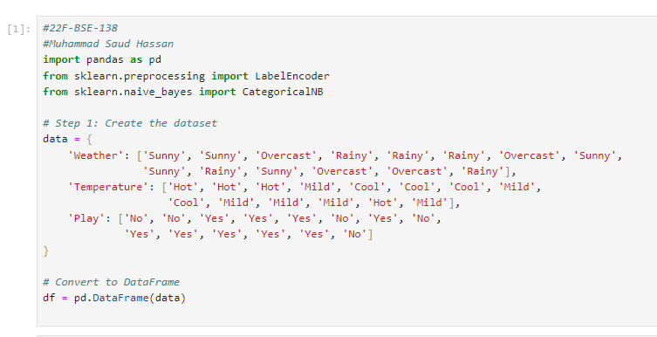

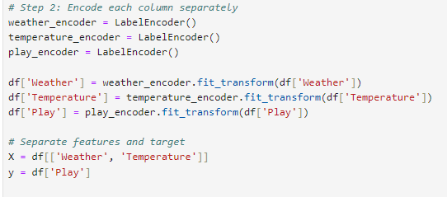

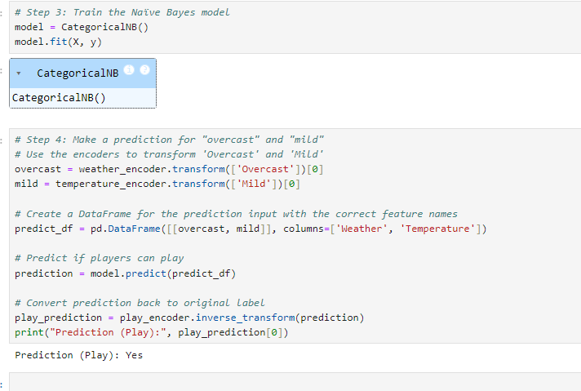

1. Consider the given dataset. Implement Naïve Bayes Algorithm to classify youth/medium/yes/fair**.**

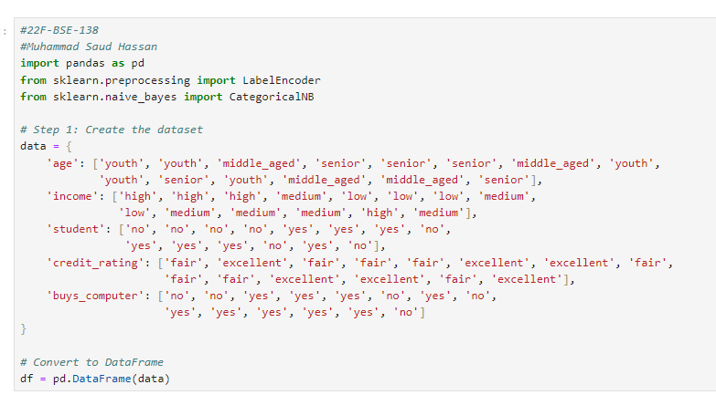

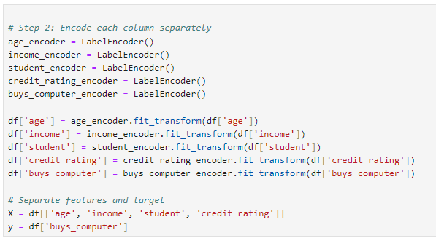

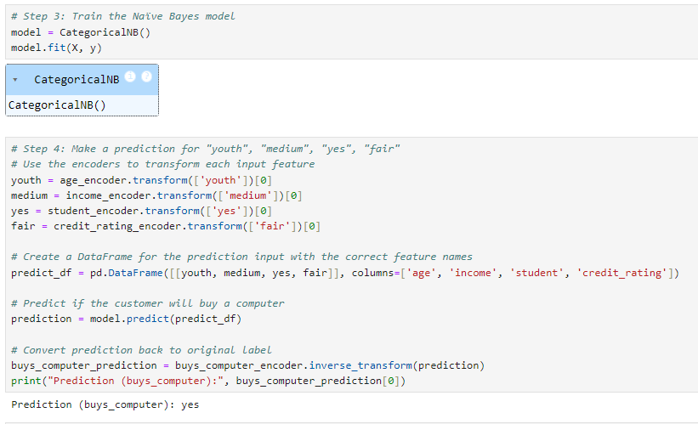

**Home Tasks:**

Using Naïve Bayes Algorithm, predict whether a student will pass or fail based on their study hours, attendance, percentage and participation in extra circular activities.

